Software Requirements Specification
for
Course Registration Online
Version 1.1 approved
Prepared by Kevin Vang
The University of Arizona Global Campus
12/15/2023
Table of Contents
Table of Contents ii
Revision History ii
1. Introduction 1
1.1 Purpose 1
1.2 Product Scope 1
1.3 Problem Discription 1
1.4 Impact 1
1.5 Solution Overview 1
1.6 Reference…………………………………………………………………………………………1
2. Functional Requirements 2
2.1 Course Availability 2
2.2 Guidance Support 2
2.3 Non-Functional Support 2
2.4 Perfomance 2
2.5 Constraints 2
2.6 Security 2
2.7 Assumptions and Dependencies 3
3. External Interface Requirements 3
3.1 User Interfaces 3
3.2 Hardware Interfaces 3
3.3 Software Interfaces 3
3.4 Communications Interfaces 3
4. System Features 4
4.1 System Feature 1 4
4.2 System Feature 2 (and so on) 4
5. Other Nonfunctional Requirements 4
5.1 Performance Requirements 4
5.2 Safety Requirements 5
5.3 Security Requirements 5
5.4 Software Quality Attributes 5
5.5 Business Rules 5
6. Other Requirements 5
Appendix A: Glossary 5
Appendix B: Analysis Models 5
Appendix C: To Be Determined List 6

Revision History
Name | Date | Reason For Changes | Version
Kevin Vang | 12/15/2023 | Additional information | 1.1

Introduction

Purpose
The purpose of this document is to address and identify the problem of students enrolling into online courses and provide a comprehensive solution to overcome the challenges associated with this issue.

Product Scope
This SRS document will focus on the identification and analysis of the problem, as well as the proposed solution to improve the enrollment process for online courses (Sharma et al., 2014).

Problem Description

The current enrollment process for online courses is inefficient and leads to various challenges for students. These challenges include:

a) Limited course availability: Students often face difficulties in finding the desired courses due to limited availability or lack of information regarding the courses offered.

b) Complex registration process: The current registration process for online courses is often complex and time-consuming, requiring multiple steps and documentation, which discourages students from enrolling.

c) Lack of guidance and support: Students may lack proper guidance and support during the enrollment process, leading to confusion and frustration (Haron et al., 2014).

Impact

The problems mentioned above have a significant impact on the students and the overall effectiveness of online education. The consequences include:

a) Decreased enrollment rates: Difficulties in finding courses and complex registration processes lead to decreased enrollment rates, limiting the reach and impact of online education.

b) Student dissatisfaction: The lack of guidance and support during the enrollment process results in student dissatisfaction, affecting their overall learning experience (Sharma et al., 2014).

Solution Overview

To address the identified problems, a comprehensive solution is proposed. The solution will include the following key components:
a) Enhanced course availability: Implement a centralized platform that provides comprehensive information about available online courses, including course descriptions, schedules, and prerequisites.

b) Streamlined registration process: Develop a user-friendly registration system that simplifies the enrollment process, reduces the number of steps, and provides clear instructions to students (Sharma et al., 2014).

c) Improved guidance and support: Establish a support system, such as a dedicated helpdesk or chatbot, to assist students during the enrollment process, answer their queries, and provide guidance.

Reference

Haron, A., Sahibuddin, S., Harun, M., Taib, M. M., & Botok, A. G. (2014). SRS development procedure: the roles and responsibility of key IT personnel in requirement engineering process. International Journal of Computer and Electrical Engineering, 6(2), 105.

Sharma, A., Vardhan, M., & Kushwaha, D. S. (2014). A versatile approach for the estimation of software development effort based on SRS document. International Journal of Software Engineering and Knowledge Engineering, 24(01), 1-42.

Functional Requirements

Course Availability

2.1.1 The system shall provide a searchable catalog of available online courses.

2.1.2 The system shall display detailed course descriptions, including learning objectives, syllabus, and instructor information.

2.1.3 The system shall provide information about course schedules, including start and end dates, session durations, and class timings.

Guidance and Support
2.2.1 The system shall provide an online helpdesk or chatbot to assist students during the enrollment process.

2.2.2 The helpdesk or chatbot shall be capable of answering frequently asked questions and providing guidance on enrollment-related queries.

2.2.3 The system shall have a feedback mechanism to collect students' suggestions and address any issues or concerns.

Non-Functional Requirements
2.3 Usability
2.3.1 The system shall have a user-friendly interface with intuitive navigation and clear instructions.
2.3.2 The system shall be accessible on multiple devices, including desktops, laptops, and mobile devices.

Performance

The system shall have a fast response time to ensure a seamless user experience during the enrollment process.

2.4.2 The system shall be capable of handling a large number of concurrent users without performance degradation.

Constraints
2.5.1 Technical Constraints
The proposed solution should be compatible with existing online learning platforms and integrate seamlessly with the institution's infrastructure.

2.5.2 Budget Constraints
The solution should be cost-effective and consider the institution's budget limitations.

Security
5.3.1 The system shall implement appropriate security measures to protect student information and prevent unauthorized access.

External Interface Requirements

User Interfaces
User interface allows students to enroll for courses,

Hardware Interfaces
- Outline the physical connectors, ports, and interfaces used for linking the software to the hardware. Consider aspects such as USB ports, HDMI connectors, audio jacks, and any other hardware-specific interfaces.

Software Interfaces
- Connections:Interacts with the backend server through HTTP/HTTPS protocols.
Utilizes JavaScript for client-side interactions.
-Data Items/Messages In and Out:Receives user input data (registration details, course selections).
-Sends requests to the backend for user authentication, registration, and course information.
-Receives responses containing user data and course details.
- Services and Communications: Utilizes RESTful API endpoints for communication with the backend.
-Communicates asynchronously for real-time updates.
- Backend Server (PHP, MySQL)
-Connects to the MySQL database for data storage.

Communications Interfaces
<Describe the requirements associated with any communications functions required by this product, including e-mail, web browser, network server communications protocols, electronic forms, and so on. Define any pertinent message formatting. Identify any communication standards that will be used, such as FTP or HTTP. Specify any communication security or encryption issues, data transfer rates, and synchronization mechanisms.>

System Features

UML model:Use Case Model

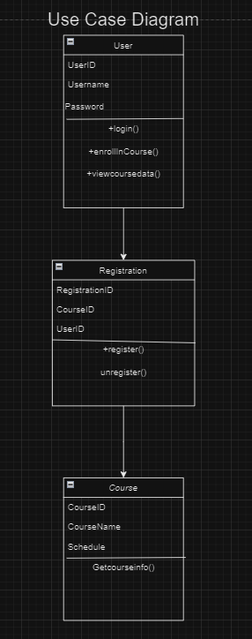

Landing, Login, and Enrollment Pages.

Landing Page

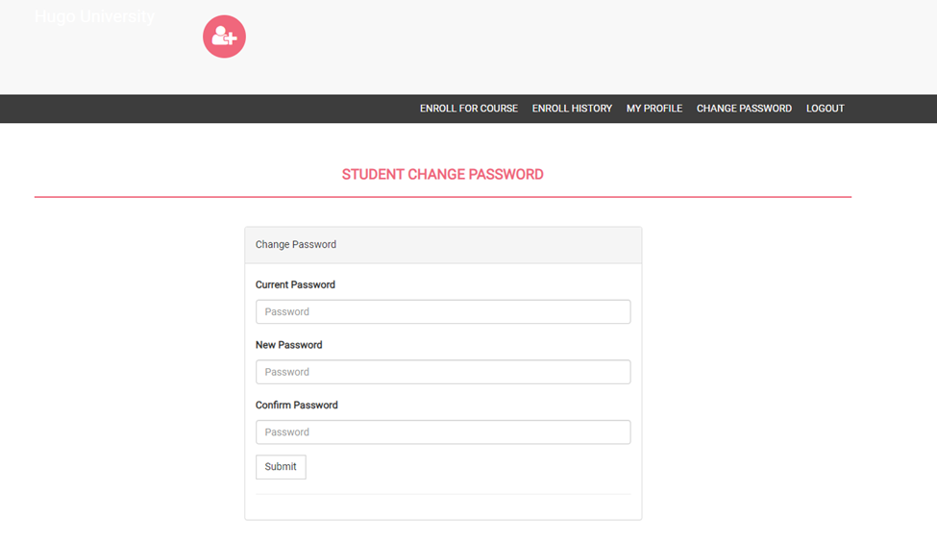

Login Page

.



Enrollment Page



Enrollment Page Continue



In the development lifecycle of a web application, several key phases are crucial for creating a robust and user-friendly registration system. Beginning with planning, the features and functionalities needed for each page are identified, along with determining the data to be collected during enrollment. The database structure is strategically planned to ensure secure storage of user information. The design phase involves creating wireframes, user-friendly layouts, and selecting visual elements in alignment with the brand. Moving to frontend development, HTML, CSS, and JavaScript are utilized for implementing the design, often leveraging frameworks like Bootstrap or React, while client-side validation ensures immediate user feedback. Backend development involves scripting in languages such as PHP or Node.js, creating endpoints for registration, login, and enrollment, and integrating secure database interactions.

In the database integration phase, a relational database system (e.g., MySQL) is chosen, and tables are designed for storing user data. A secure connection is established, and measures like prepared statements prevent SQL injection. The user registration process involves server-side validation, password hashing for security, and the creation of a unique user identifier. For user login, credentials are validated on the server side, and a session or token is created upon successful authentication. The enrollment process is then implemented, updating the database to reflect user course preferences. Thorough testing, including unit, integration, and user acceptance testing, ensures the functionality of each page.

Upon successful testing, deployment involves hosting the application on a web server, with domain configurations if necessary. The final steps include implementing monitoring tools for user activity tracking and system performance, and regular updates and maintenance to address security vulnerabilities and enhance features. This comprehensive approach ensures a systematic and effective development process for a successful web registration system.

Registration Page

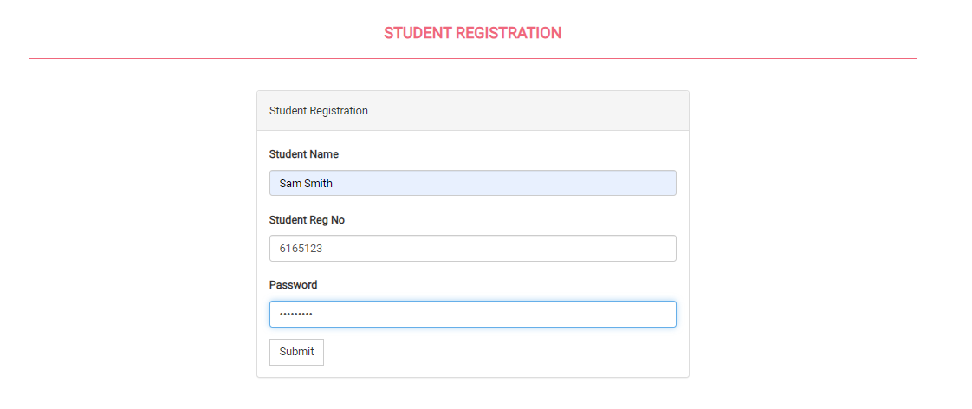

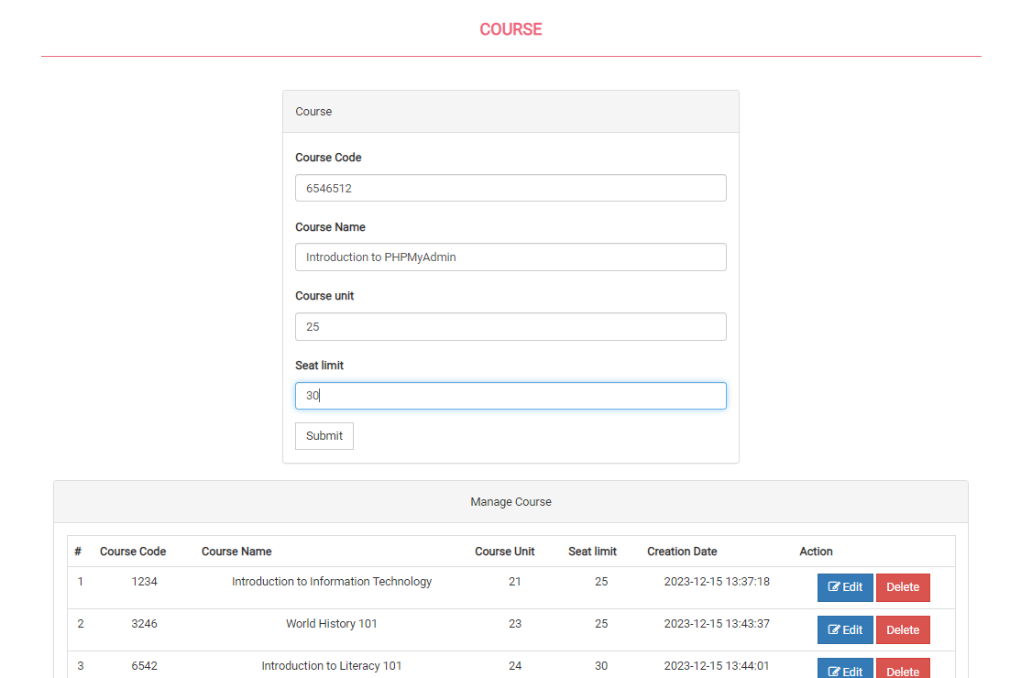

MySQL Database

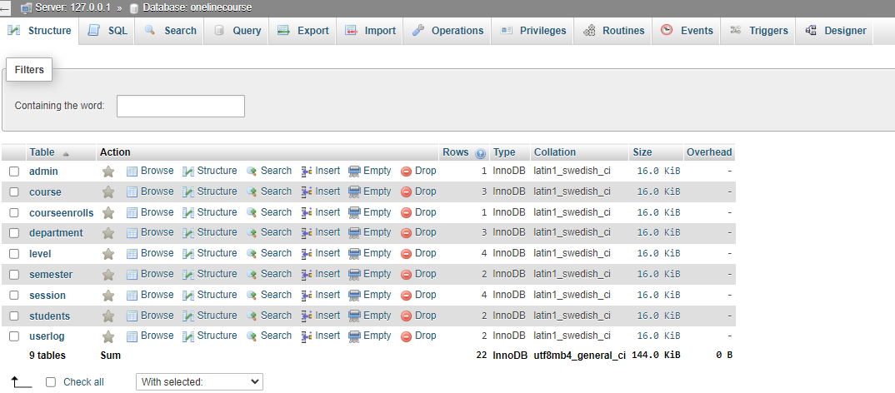

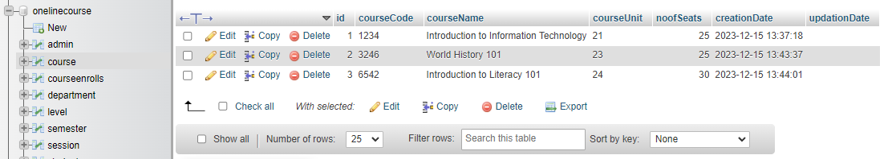

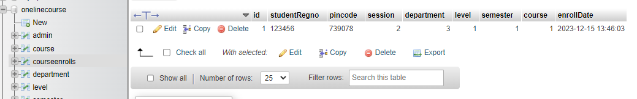

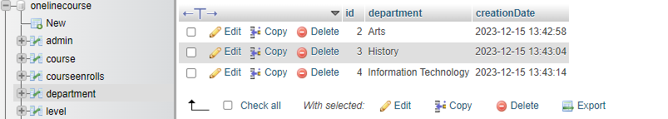

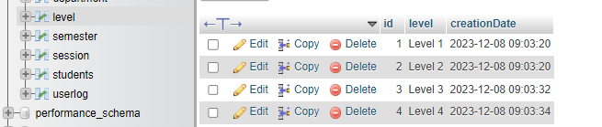

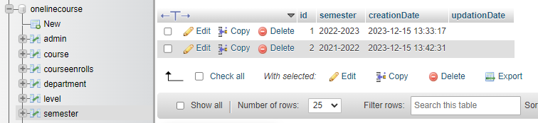

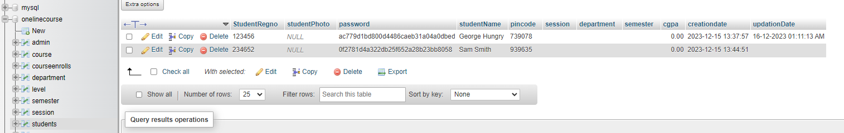

PHP Code
Included in GitHub.

Reference

Connolly, R., & Hoar, R. (2018). Fundamentals of web development (2nd ed.). Pearson.

Haron, A., Sahibuddin, S., Harun, M., Taib, M. M., & Botok, A. G. (2014). SRS development procedure: the roles and responsibility of key IT personnel in requirement engineering process. International Journal of Computer and Electrical Engineering, 6(2), 105.

Mikoluk, K. (2013, September 18). XAMPP tutorial: How to use XAMPP to run your own web server. Udemy. https://blog.udemy.com/xampp-tutorial

Sharma, A., Vardhan, M., & Kushwaha, D. S. (2014). A versatile approach for the estimation of software development effort based on SRS document. International Journal of Software Engineering and Knowledge Engineering, 24(01), 1-42.

Tsui, F., Karam, O., & Bernal, B. (2018). Essentials of software engineering (4th ed.). Jones & Bartlett Learning.

Wang, X., Sun, W., Hu, L., Zhao, Y., Wong, W. E., & Chen, Z. (2019). Software-testing contests: Observations and lessons learned. Computer, 52(10), 61–69. https://doi.org/10.1109/MC.2019.2905533

